FINAL PROJECT PROPOSAL

CMST 385 | Richard Gray

## CLIENT AND TOPIC

The client for this project will be a freelance digital design agency. It should feature past work experience, case studies/blog posts, and contact information about the business.

## DEVELOPMENT PROCESS AND ENGAGEMENT

In order to maximize engagement, I’ll research other freelance digital design agencies and their SEO strategies. This will include using semrush.com to view their monthly visitors, and see what sorts of sites they have backlinks from. This will help increase engagement when potential users/customers look for a digital design agency on google. The first step will be to analyze SEO keywords, backlinks, and traffic sources (including geo/device information if available) from the digital design agency list provided by clutch.co. By targeting the proper platform and user base, I can be sure to design and develop for my particular customers’ needs.

## TESTING

The site will be tested on multiple browsers to ensure compatibility. Namely, Chromium based, Edge, Safari, and Firefox. Additionally, multiple screen sizes will be tested for desktop, mobile, and potentially tablet. However, if SEO research turns up that visitors from tablets are low (8% or less), this test may be omitted. Screen sizes will be tested using both the inspector’s variable screen size as well as native on devices such as iPhone. User testing will also be conducted by sending the site to multiple people to gather insights from various screen sizes.

## BUSINESS AND WEBSITE DESCRIPTION

## Mission Statement

Provide informational websites and SEO analytics to increase traffic, engagement, and conversion rates for small to medium-sized business clients.

## Business Goals

This will be a brand new business with no clients, so the business goals will include:

* Gain at least one new client (stretch 2 clients)
* Increase traffic to client’s site by 30%
* Increase business revenue after operating costs to $1,000/month

## Market Segment and Target Audience

The primary market segment for this will be people who are small to medium business (SMB) owners. They should have the following characteristics:

* Business Size: Small to medium (500 employees or less) (investopedia.com)
* Revenue: $52,000 ± $24,000 ($28,000 - $76,000) (sobanco.com)
* Industry: Most likely services

The target audience is local services businesses who want to increase their online presence. These include:

* Dental/vision services
* Local retailers
* Food and Drink businesses

User Demographics:

* Age: 35-50+
* Occupation: Business owners
* Primary technology used:
  + Device: Mobile, Desktop
  + Browsers: Chrome, Safari, Firefox, Edge

## Target Audience Impact

The purpose of targeting this segment and audience in particular would be to market the sites services to business owners who have expendable income and want to increase their business traffic and conversion rates. As such, the site should look reputable and applicable to a broad range of industries. The site should act as a template for their site, since they’re most likely not going to read the blog posts and only spend 10-20 seconds on the page (nngroup.com). Due to this limited view time, it’s important for the site to have a clean design that the user could see their content on.

## Content

The site will consist of a few blog posts highlighting the importance of web design for small business. From there, I can write a few other blog posts with key words from a “People Also Ask” (PAA) service like <https://answersocrates.com/> or <https://keywordspeopleuse.com/>. From these sites, I found a few potential blog post topics such as:

* What Should A Small Business Website Contain
* Does A Small Business Need A Website
* Why Small Business Need Website

Other content needs for the site such as images can come from pexels or google search. It will also contain a portfolio which at first will have a few mock projects in it just to show people what the service is capable of.

## Updates

Ideally, the website’s content would be updated quarterly with analytics to highlight certain pages, or to increase content on hot keywords related to the domain for that quarter.

## GROWTH AND MAINTENANCE

The website should scale, but should also scale sustainably. Ideally, the business could take on 2-3 clients per month, which could grow as processes improve. To make the website easier to maintain, it should employ blog post templates that are reusable in order to reduce complexity when updating the site. Additionally, the portfolio should be in a templatized format to easily add the results from new clients to the site. To make the site easy to maintain, some work will have to be done in the beginning of the project to ensure that pages can be reused. Updating site content will likely happen once every 3 months

## ORGANIZATION

## Site Map

This is the site map for the final project:

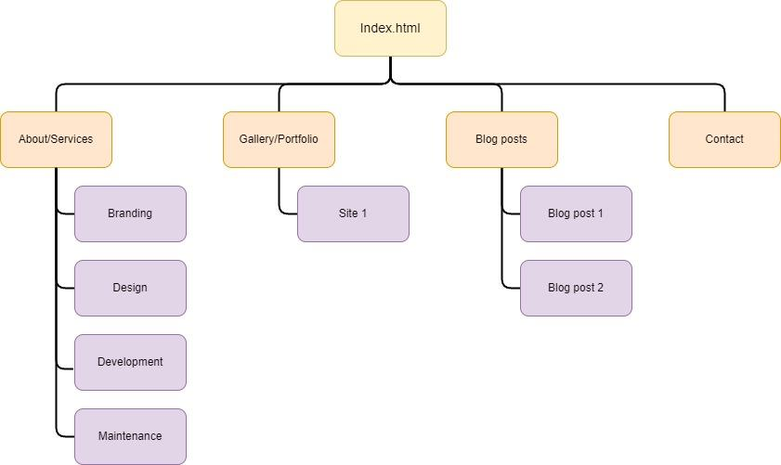

## Wire Frame Examples

## 

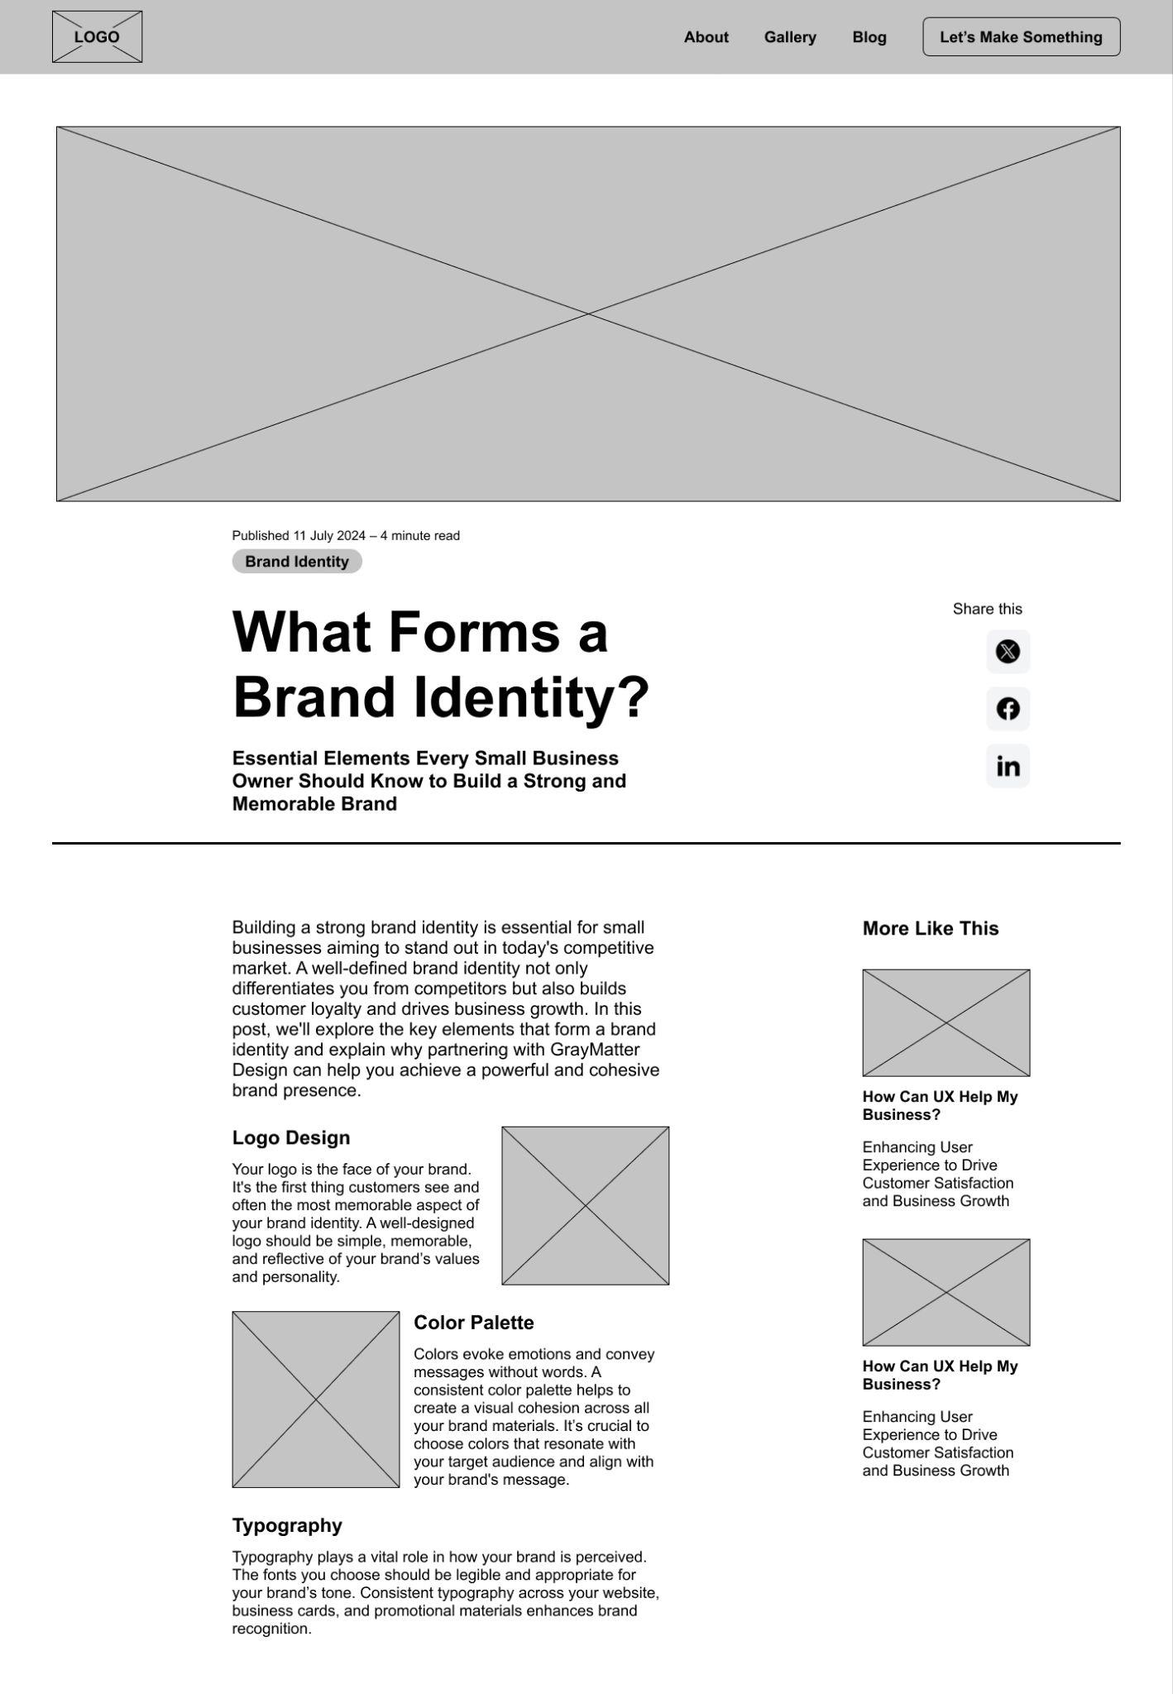

*Not all wireframes included

## WEB HOSTING

Since this will mainly be a static site with some light interactivity for the contact us page, I would likely use AWS Amplify for this site since traffic is expected to be low and I can therefore save costs since Amplify is free. Additionally it would be good to have all sites hosted on one platform to make it easier to manage. Since AWS is considered a standard in web hosting, it would be beneficial to have all business sites managed under one account with Amplify. The website will need to support HTML and CSS, with some potential for JavaScript if there is special interactivity involved.

The domain graymatterdesign.studio is currently available for purchase via porkbun.com for $11.82 for the first year and renews at $25.21/year after that. Since the term “gray matter” is rather ubiquitous, it might be beneficial to consider a rebrand of the site itself to make a name that is more catchy and appealing.

## MARKETING

The site will be marketed on channels such as instagram, but primarily facebook since that is their demographics more adequately align with those of the target demographic (sproutsocial.com). As far as tactics go, any advertisements should appeal to the target demographic. Since the target demographic would be older Millennials/Gen X, there are a few marketing strategies that I could employ:

* Authentic Marketing (bigcommerce.com)
* Facebook/video channels (bigcommerce.com)
* Search functionality embedded in site (bigcommerce.com)
* Nostalgic qualities (spotify.com)
* Demographic specific targeting (spotify.com)
* Incorporate written reviews (spotify.com)

With these marketing tactics and appealing visuals, I can hone in on the Gen X market segment and show them ads on the channels they interact with the most to properly guide them to the site and increase conversion rates.

## 

## SECURITY

This will be a relatively simple informational site with a contact form, so there will likely not need to be Fort Knox levels of security, although it is good to incorporate modern web security best practices such as:

* Https through SSL/TLS certification
* Input validation and sanitization
  + If there is a backend this is important to prevent SQL injection and cross-site scripting attacks
* AWS Shield
  + This is a service that AWS provides which prevents DDoS attacks
* Monitor and Log Activities
  + Using AWS CloudWatch, I can monitor site activities and set up alerts for anything that looks suspicious or malicious

## PROJECT REFLECTION

This project really stretched my abilities to research. Both on the web tech side of things, as well as marketing, which albeit I do not have much experience with. Coming from a UX Design background however, marketing is a very tangential field with demographics and personas, so it was relatively easy to pick up on some core concepts that I already had familiarity with.

The only real issues I faced had to do with research. I did a fair bit of looking into best practices when it comes to SEO and marketing, but ultimately, I believe I was successful in grasping the basics. I did have one issue with Figma when creating the wires, but that was mainly due to the fact that I was trying to incorporate a parent component nested in a frame into another component, which Figma doesn’t allow. But after I figured that out, it was smooth sailing. I had fun with this project it was a good challenge!

Tech used:

* <https://draw.io> for the site diagram
* Figma for the wireframes
* Google docs

## 

## REFERENCES

<https://www.investopedia.com/terms/s/smallandmidsizeenterprises.asp>

<https://altline.sobanco.com/small-business-revenue-statistics/>

<https://clutch.co/agencies/digital-design>

h[ttps://www.nngroup.com/articles/how-long-do-users-stay-on-web-pages/](https://www.nngroup.com/articles/how-long-do-users-stay-on-web-pages/)

<https://draw.io>

<https://sproutsocial.com/insights/new-social-media-demographics/#facebook>

<https://www.bigcommerce.com/blog/gen-x-marketing/>

## 